



Modelling Service Domains in Archimate

Tool Mentor Paper

Table of Contents

1 Modelling Service Domains in Archimate 3

1.1 Business Capabilities Map 3

1.2 API Layer 4

1.2.1 API Inventory 4

1.2.2 API Specification 5

1.2.3 API Resources Specifications 9

1.3 Core Domain 9

1.3.1 Aggregates 10

1.3.2 Aggregate and Entity Lifecycle Diagrams 11

1.3.3 Commands Specification 12

1.3.4 Service Specifications 14

1.3.5 Query Specifications 16

1.3.6 Domain Events 18

1.3.7 Objects 19

1.4 Integration Layer 21

1.4.1 External Events 22

1.4.2 Events Handlers 23

1.4.3 External API and External Domains 24

1.4.4 External Services 25

Document Information

|  |  |  |  |
| --- | --- | --- | --- |
| **Project Name:** |  | | |
| **Prepared By:** | Alfredo Muñoz | **Document Version No:** | 1.0 |
| **Title:** | Tool Guidance – Modelling Service Domains with Archimate | **Document Version Date:** |  |
| **Reviewed By:** |  | **Review Date:** |  |

Document Version History

| **Version Number** | **Version Date** | **Revised By** | **Description** | **Filename** |
| --- | --- | --- | --- | --- |
| 1.0 |  |  |  |  |
|  |  |  |  |  |

# Modelling Service Domains in Archimate

## Business Capabilities Map

Business Capability Maps describes, from a Strategic level, the Business Capabilities provided by the Domain. It is placed in the Domain Folder of the Archimate Template.

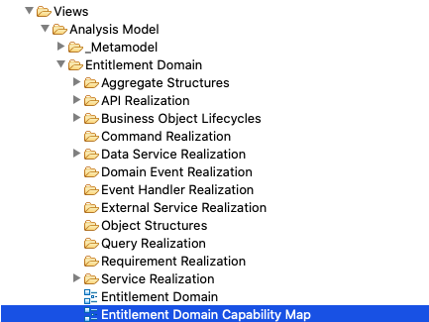

Business Capabilities Map uses “**resources**” and “**capabilities**” objects type in Archimate. **Domains** and **Sub-domains** are modelled as Resources and **Business Capabilities** as Capabilities. All the elements are placed under the respective folders

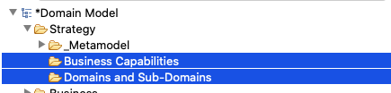

The following picture is the template for Capability Maps:



## API Layer

API layer is described with API, API responses and API resources.



The API layer never implement business logic, but uses Commands, Queries and Services to access the data and business logic implemented in the Domain.

Commands, Queries and Services are components from the Core Domain and are further described in the corresponding section

### API Inventory

API are created in Archimate template under the Business/API Folder

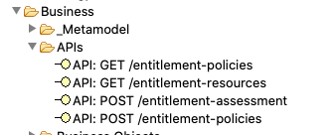

Use the Property Tab to provide the name and description:

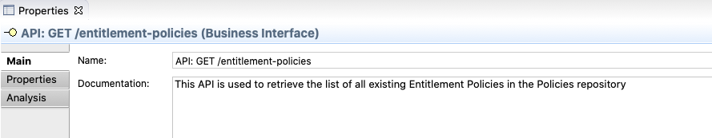

Set the “Type” in the Property Field to “API¨:

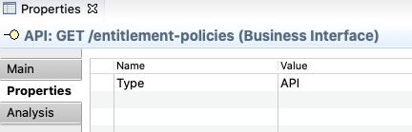

### API Specification

We use API realization diagram describes the implementation of the API including the commands and services used to provide the business logic and data required the API. The API realization diagrams are in the folder as shown below:

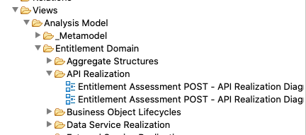

Model of Diagram:

#### Requests

Requests resources are modeled with API Resources (Entity objects in Archimate)

API resources are placed in the API Resource Folder

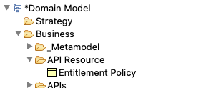

Use the Property Tab to enter name and description, and classify the element as “API Resource” or copy/paste one from the metamodel folder

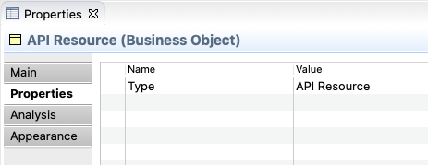

#### Responses

Responses are modeled with Response objects (Representation objects type in Archimate) Each Response has associated an Entity, which models the resource (the data) provided in the response.

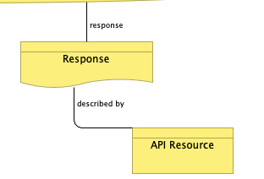 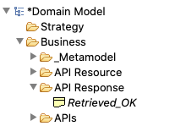

Responses are placed in the API Response folder

Use Properties to set name and description. Do not reuse. Each Response may have a different output resource associated for each different API

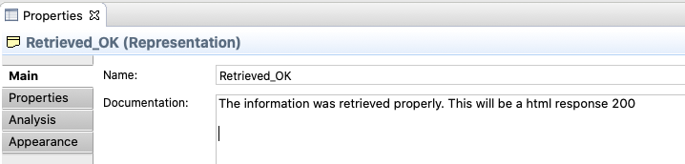

Create a property Type with “API Response”

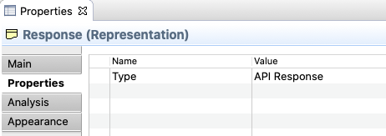

The valid responses types can be found in the API responses folder and the “Metamodel: API Response” View

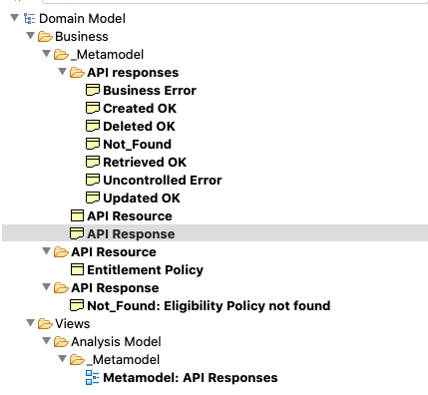

Valid Responses are shown below. Copy and Paste one of them to create a response for your APIs



#### API Realization

The Diagram describes the Services, Commands or Queries in the Core Domain that the API uses to provide the responses.

We use the Logic Descriptor to write down the logic to be implemented in the API, such as data mappings, validations, etc.



The API receives or send a payload described by Entities, as described above, and the commands, services or query will have their own interface. The data in the API must be mapped to the interfaces. When API payloads and Services, Command or Queries interfaces are not clearly similar, mapping instructions should be provided. To do so, a “logic descriptor” element is used

We´ll use simple text to describe how mapping is to be done. The analyst is welcome to use tables such as the one below. This cannot be achieved in Archimate and should be a necessary manual step when creating the deliverable in MS Word.

| **Target Field** | **Source Field** | **Comments** |
| --- | --- | --- |
|  |  |  |
|  |  |  |

### API Resources Specifications

API resources are modeled as Business Objects, following the same approach. Please see the “Objects” sections of this guide

## Core Domain

The Core Domain implement the business logic and will manage the data of the domain. It uses the integration layer to access external services and data. It is used by the API layer to expose the services provided by the domain.



The Core Domain is described by:

* **Aggregates**, data structures used to organize the information used and managed in the domain. **Entities** and **Value** **Objects** are used to structure the aggregates
* **Commands**. Components to create and manipulate the data in the domain
* **Queries**. Similar to commands, but with the purpose of retrieving data, while commands responsibility is to create or alter the data.
* **Service**. Encapsulation of business logic for reusability or whether it is complex, and we don´t want to place complex logic in the commands.
* **Domain Event** are used to publish information on changes in the states of the domain aggregates

### Aggregates

Aggregates are the elements used to model the information managed or use within the domain and provides the ubiquitous language of the Domain

Aggregates are described using “Aggregate Structure Views”. These views are under the “Aggregate Structure” folder in the template

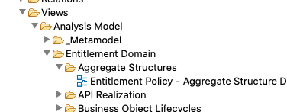

The following is the template for an aggregate structure.



An aggregate is made or a root-entity and includes entities. Both root-entities and entities are modeled as Objects. See 7.9 for instructions on Object Modelling.

Aggregates are created as Root-Entity objects and placed in the Business Object folder of the templated

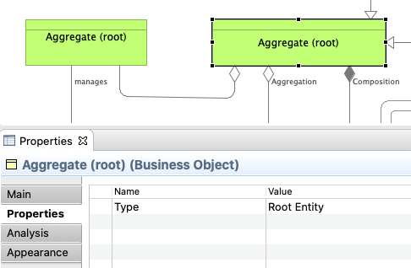 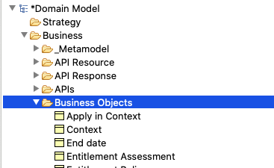

Entities are defined as Type: Object and placed in the same folder.

### Aggregate and Entity Lifecycle Diagrams

These diagrams describe the states of the lifecycle of aggregates and entities, the allowed transitions between states and the pre-conditions (constrains) for such transitions

These diagrams are placed under the **business object lifecycle** folder in the template:

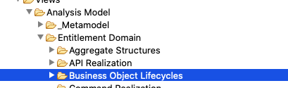

Next picture describes the Template for this type of diagram. It includes the states, the entities and aggregate of the states, the valid flows between states and the commands that will cause the state transition.



### Commands Specification

Commands are the components in charge of creating or modifying the data in the aggregates. They are called whenever new data has to be persisted in the domain

Commands are modeled using Business Services elements in Archi within the folder “Commands”. Commands are described in Command Realization Diagram. Diagrams are placed under Command realization folder

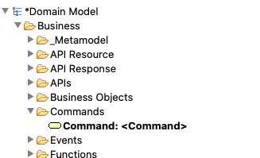 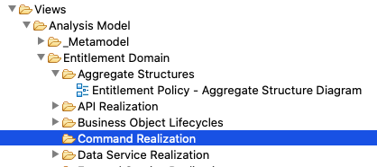

The commands (such as the queries and the services) implement the business logic in the domain. Logic is described in Logic Descriptor elements as simple text in the Documentation space of the Properties of the element. We also create flows using Task elements to provide clarification. We use specifically Tasks to detail the mapping instructions to the interfaces of the services called. Logic Descriptors and Task are created using the Business Function object in Archimate and classifying them with a Type Attribute:

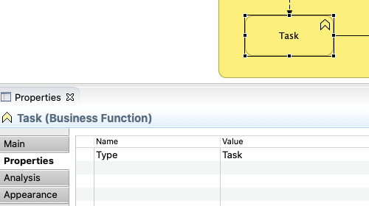 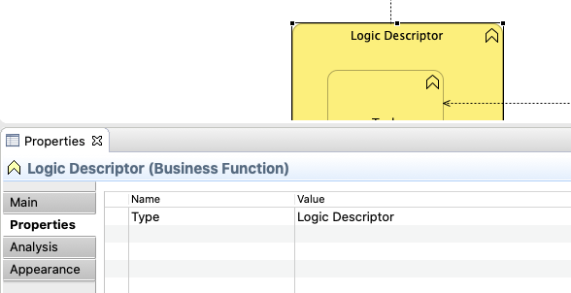

Next picture shows the template for the Command Realization. It the picture we can see:

* **Interfaces** of the Command (input / outputs) are described using entities;
* The first Task describes a step when we are retrieving data from an **aggregate** or an **entity**. The task description should provide the necessary instructions to explain the designer how the access is done (i.e retrieve a “Policy Criteria” using the Criteria ID…);
* The second Task describes a step when we are calling an **External Service**. The task description should provide the necessary instructions to explain to the designer how to call the service (how to populate the input interface of the called services) will be done;
* The third Task describes a step when we are calling a **Domain Service**. The task description should provide the necessary instructions to explain to the designer how to call the service (how to populate the input interface of the called services) should be done;
* The fourth Task describes a step when we persist data into the domain. The task description should provide the necessary instructions to explain to the designer what entity is created, updated or deleted;
* The last Task generates a **Domain** **Event**. The task description should provide the necessary instructions on how to populate the information required to create the event.



### Service Specifications

Services are the components where we encapsulate business logic to be reused or when it´s very complicated and we don´t want to add complexity to the Commands.

Services are modeled using Business Services elements in Archi within the folder “Services”. Services are described in Service Realization Diagram. Diagrams are placed under “Service Realization” folder

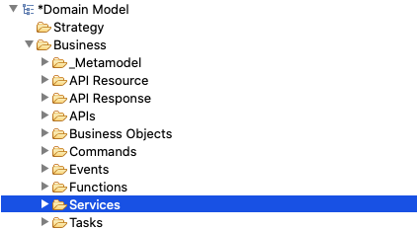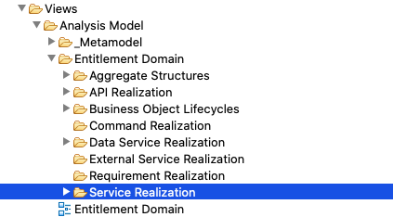

The services implement the business logic in the domain. Services are modelled like the commands. Please refer to the previous section for details on Command modeling. The only difference is that Services cannot persist data. This is exclusive of Commands. Services uses commands to alter the aggregates in the Domain.

The next picture provides a template for Services:



### Query Specifications

Services are the components we use to retrieve data based on different criteria. We only need to define a query component when we face non-standard access requirements (different of GetByID or GetAll). For example, to retrieve customers which belong to a specific group.

Queries are modeled using Business Services elements in Archi within the folder “Queries”. Queries are described in Query Realization Diagram. Diagrams are placed under “Query Realization” folder

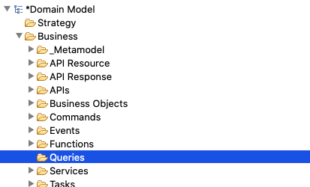 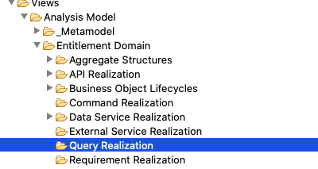

Queries are modelled like the Services. Please refer to the previous section in the document for details. The next picture provides a template for Queries realization diagrams:

### Domain Events

Domain Events are the business events emitted by the Domain for other domains to subscribe to changes in the resources of the Domain.

They are created under the “Domain Folder” and described in Domain Event Realization Diagrams.

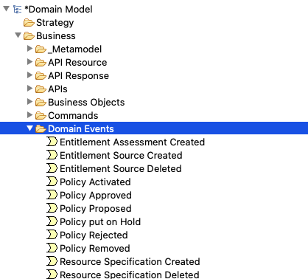 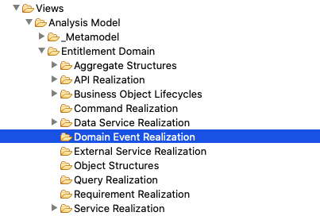

**Domain Event Realization** diagrams are simple diagram that specifies the structure of the **Events** using **Objects**



Use the property tab to provide name and description of the Domain Event:

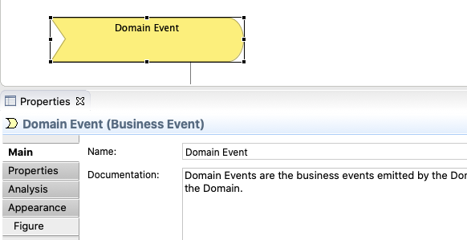

### Objects

Objects are described as “Business Entities” Archimate objects.

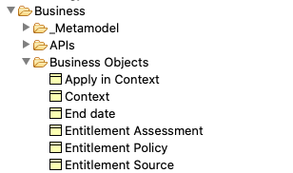

“Object Structure Views” are used to describe the Object Structures. They are placed in the Object Structure folder:

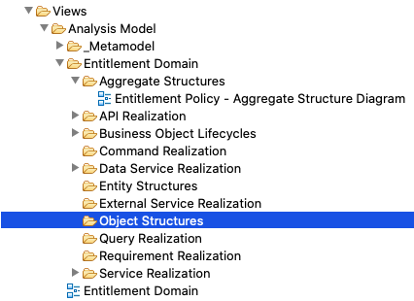

Next picture is the sample template for Object Structure View:



.

Objects contains attributes. Attributes can be primitives’ types or other objects.

To define the structure, we use aggregation and composition relationships as can be seen in the picture. We use composition for single objects and aggregation for collection of objects, when an object contains not a single, but a collection of objects in one of the attributes

Non-object attributes must be subtype with a primitive, for example the Start Data with a Data Primitive in the following figure with a sample. A not-subtyped is understood to be a complex object.

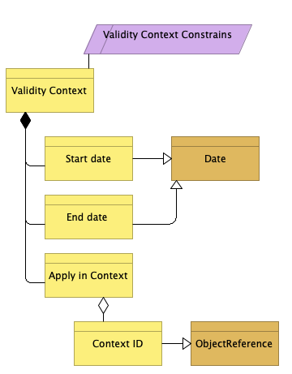

Mandatory fields and other constrains can be specified with a constrains object as in the figure. For example:

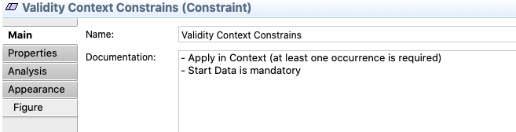

Valid Primitives can be found in the Metamodel folders:

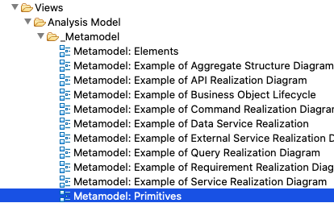 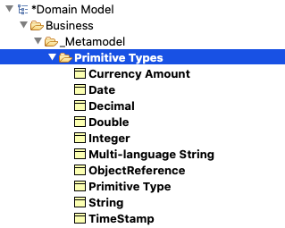

The current primitives can be see found below. New ones will be added to the template as needed:



## Integration Layer

The integration layer implements the access mechanism to data and services in other domains. Its main purpose is to transform the data received from other domain via APIs or Event to the domain language, this means to the data structures of the domain. The business logic is built exclusively using the domain data models and never data-models of other domains (i.e the payload structures of the consumed APIs)



Components in the Core Domain uses external services to access data or services in other domains, as was described in the Core Domain section of the document

Event Handlers use Commands and Services in the Core Domain to alter the domain aggregates as a result of an External Event. For example, an event informing in the change of the status of a credit offer may trigger actions in the Customer Request domain, for the customer requests related to such credit offer

### External Events

External Events are business events published by other domains that trigger any kind of response in our Domain.

For example, an event informing in the change of the status of a credit offer may trigger actions in the Customer Request domain, for the customer requests related to such credit offer

External Events are created in the **External Event** folder in the template

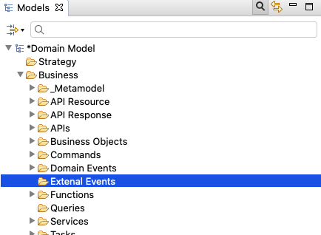

External Events are described in the Event Handler Realization Diagrams (where we specify the object used to describe the structure of the Event), and in the External Event Property Tab.

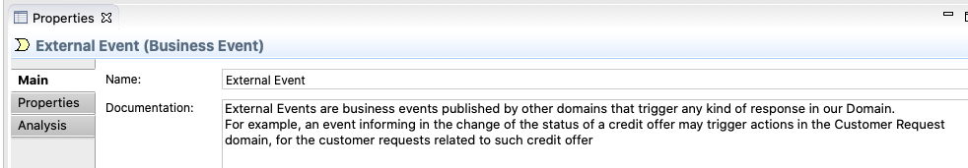

Event Handler Realization Diagrams are described in the next section of the document.

### Events Handlers

Event Handlers are components of the domains responsible to receive the event and use the information contained in the Event to trigger actions in the core domain, for example, to update information in one of the aggregates.

Event Handlers are modeled using Event Handlers elements in Archi within the folder “Event Handlers”. Services are described in Event Handlers Realization Diagram. Diagrams are placed under “Event Handler Realization” folder

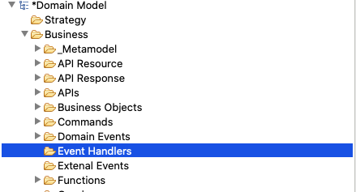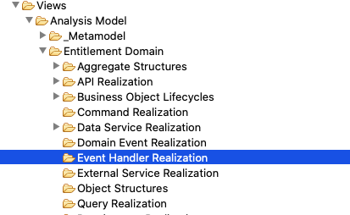

Event Handlers are modelled like the Services. Please refer to the 7.6 section for details on Service modeling. The main difference with services is that even handlers do not emit Domain Events.

The next picture provides a template for Event Handlers:



### External API and External Domains

External APIs are services provided by other domains that are used by our domain to obtain data or request a service

External APIs are created in the **External APIs** folder in the template

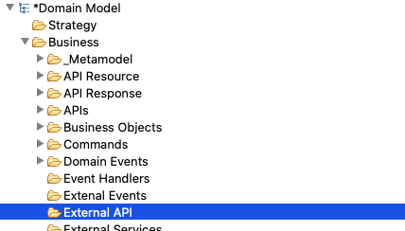

External APIs are described in the **External Service Realization** Diagrams, and in the External API Property Tab.

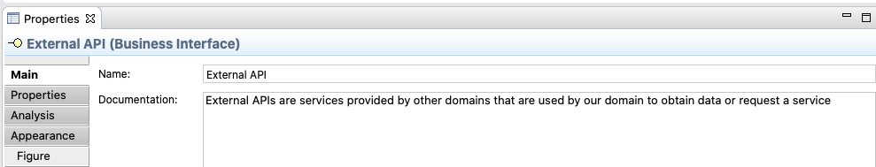

External Service Realization Diagrams are described in the next section of the document.

External Domains model the systems owners of the External APIs

External Domains are created in the **External Domains** folder in the template

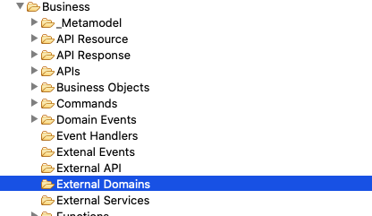

External Domains are described in the **External Service Realization** Diagrams, and in the External Domains Property Tab.

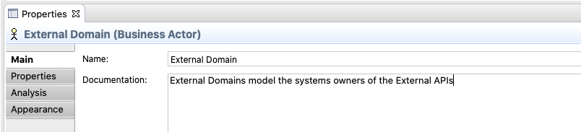

External Service Realization Diagrams are described in the next section of the document.

### External Services

External Services are the components of the domains responsible to access information of Services in other domain, by calling the APIs of those domains.

The External Services´ main responsibility is to transform the data received to the “ubiquitous language” of the domain, which means to provide the information in the structure defined by the aggregates of the Domain. This is done to avoid the business logic to rely in data elements proprietary of other domains, which would mean a strong coupling element.

External Services are modeled using Event Service elements in Archi within the folder “External Services”. External Services are described in External Services Realization” Diagrams. Diagrams are placed under “External Services Realization” folder

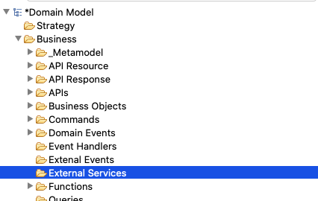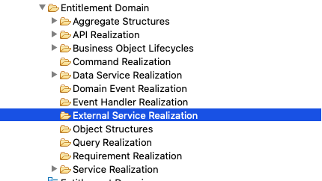

The next picture provides a template for External Services:



Next picture shows the template for the External Service Realization. It the picture we can see:

* **Interfaces** of the service (input / outputs) are described using objects;
* Tasks describing the calls **External API**. The task description should provide the necessary instructions to explain to the designer how to call the external API (how to populate the input interface of the called API) will be done;
* The **External Domain** that owns the External API
* The requirement created in JIRA for the other domain team to provide the needed API